Implement Intersite Connectivity

Lab Overview
This lab focuses on connecting multiple Azure virtual networks. You create virtual machines in separate VNets, test connectivity, enable VNet peering, and control traffic flow using custom routes (UDRs).
Estimated Time: 50 minutes
Region: East US
Resource Group: az104-rg5

Lab Scenario (Simple Explanation)
Your organization separates Core IT services and Manufacturing systems into different virtual networks for security and management reasons.
However, some applications in these networks must communicate.
In this lab, you:
- Create VMs in separate VNets
- Verify they cannot communicate initially
- Enable communication using VNet peering
- Control traffic using custom routes

Architecture diagram
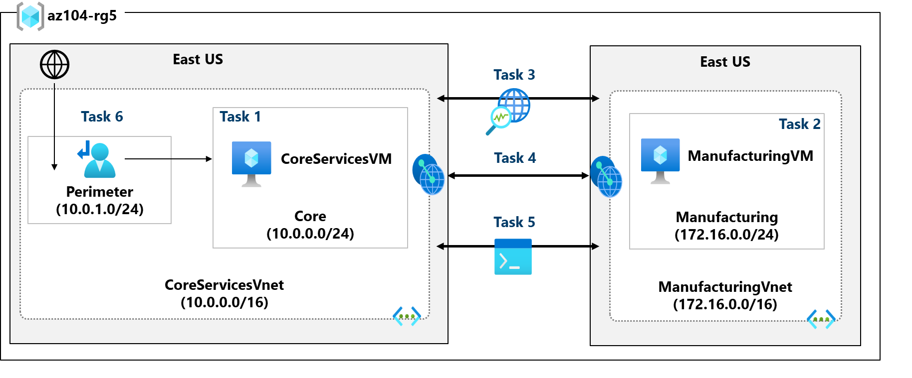

Task 1 – Create Core Services VM and VNet

Core Services Virtual Machine
Setting | Value
VM Name | CoreServicesVM
Image | Windows Server 2025 Datacenter
Size | Standard_DS2_v3
Username | localadmin
Public inbound ports | None

CoreServicesVnet
Setting | Value
Address space | 10.0.0.0/16
Subnet name | Core
Subnet range | 10.0.0.0/24
Important
- VM and VNet are created together
- No public access (private network only)

Task 2 – Create Manufacturing VM and VNet

Manufacturing Virtual Machine
Setting | Value
VM Name | ManufacturingVM
Image | Windows Server 2025 Datacenter
Size | Standard_DS2_v3
Public inbound ports | None

Manufacturing Vnet
Setting | Value
Address space | 172.16.0.0/16
Subnet name | Manufacturing
Subnet range | 172.16.0.0/24

Task 3 – Test Connectivity Using Network Watcher (Before Peering)

Tool Used
Azure Network Watcher → Connection Troubleshoot

Test Configuration
Setting | Value
Source VM | CoreServicesVM
Destination VM | ManufacturingVM
Protocol | TCP
Port | 3389 (RDP)

Result
Connectivity Status: Unreachable
Reason:
Virtual networks are isolated by default.

Task 4 – Configure Virtual Network Peering

Peering Configuration
You create two peering links (bi-directional).
From | To
CoreServicesVnet | ManufacturingVnet
ManufacturingVnet | CoreServicesVnet

Key Settings
- Allow virtual network access ✔
- Allow forwarded traffic ✔
- Peering status: Connected
Result
- VNets can now communicate privately
- Traffic uses Microsoft backbone network

Task 5 – Test Connectivity Using PowerShell

Get CoreServicesVM Private IP
- Note the private IP address from the VM overview

Test from ManufacturingVM
Run the following command using Run Command:
Test-NetConnection <CoreServicesVM-Private-IP> -Port 3389

Result
TcpTestSucceeded : True
Conclusion
- VNet peering is working correctly

Task 6 – Create a Custom Route (User Defined Route)

Create Perimeter Subnet
Setting | Value
Subnet name | perimeter
Address range | 10.0.1.0/24

Create Route Table
Setting | Value
Name | rt-CoreServices
Propagate gateway routes | No

Create Custom Route
Setting | Value
Route name | PerimetertoCore
Destination | 10.0.0.0/16
Next hop type | Virtual appliance
Next hop IP | 10.0.1.7

Associate Route Table
Setting | Value
Virtual network | CoreServicesVnet
Subnet | Core
Result
- Traffic from Core subnet is forced through a future Network Virtual Appliance (NVA)

